4. Create a simple cloud software application for Car Booking Reservation System using any Cloud Service Provider to demonstrate SaaS.

**STEP1: GOTO ZOHO.COM**

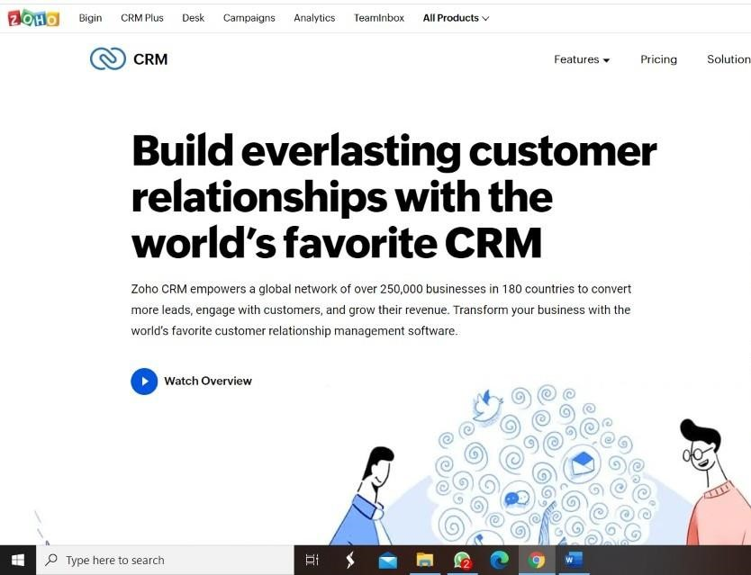

#### STEP 2: LOGINTOTHE ZOHO.COM



#### STEP 3: SELECT ONE APPLICATION

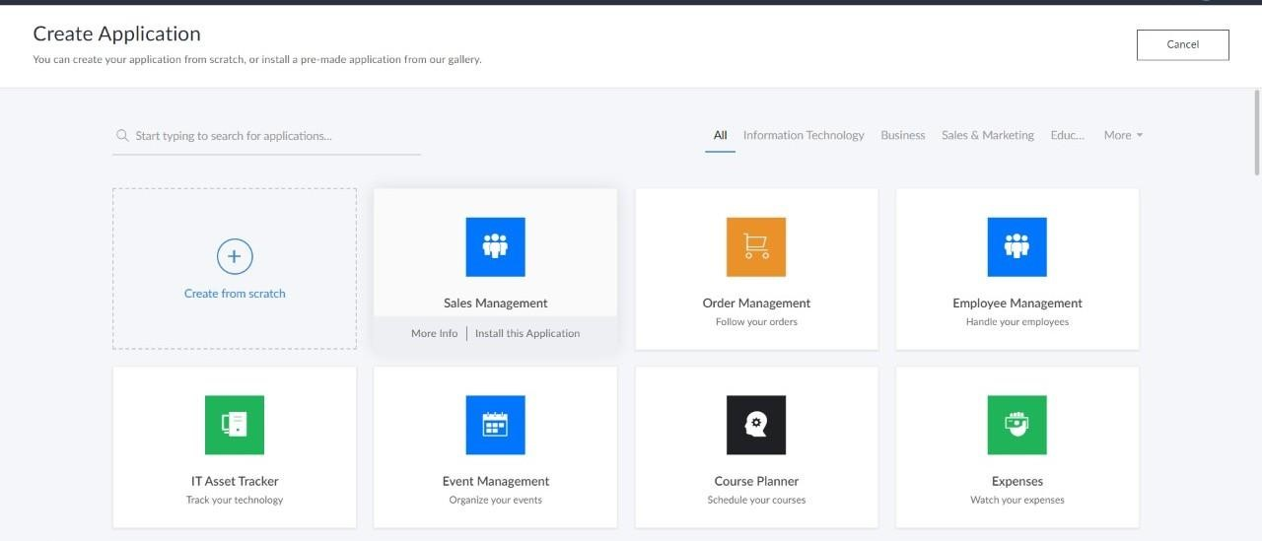

**step4:** Enter application name as Car Booking Reservation System

